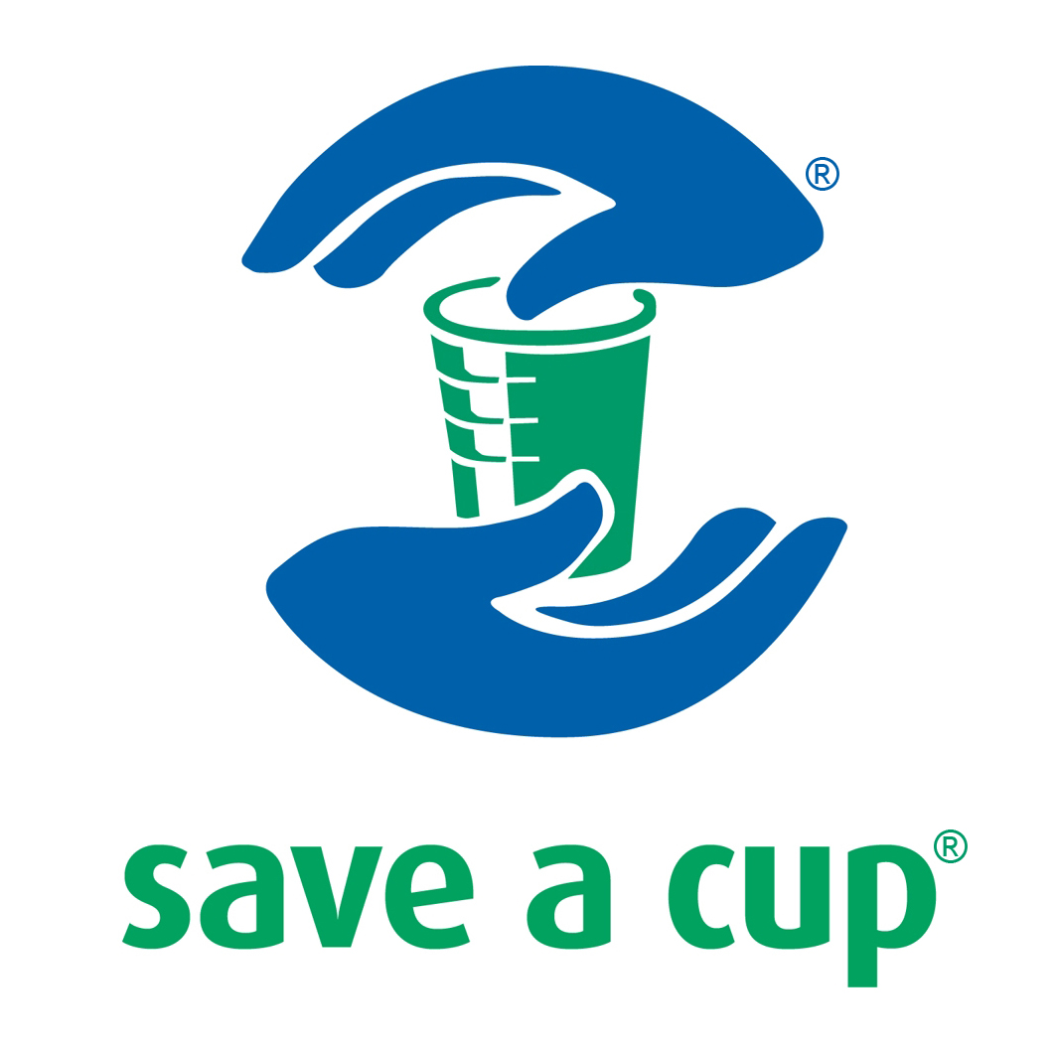
Schedule 1: Your Details

Date of Contract:
Company Name (“Customer”) & C/O
Legal Form: | LTD / PLC / LLP / Sole Trader / Partnership / Other (Delete as appropriate)
Contact Name:
Contact Number:
E-Mail Address:
Collections Commence:
Purchase Order Number:

Address for Invoices: | Billing Contact Name:
 | Billing Contact Number:
 | Billing Email Address:
Site Address for Collections: (“Site”)  Additional Sites Sheet Attached | Site 1 Contact Name:
 | Site 1 Contact Number:
 | Site 1 Contact Email:

Schedule 2: Your Requirements

Please Select Waste Streams to be Collected (“Material”):  Please Tick as Appropriate | Polystyrene PS06 Vending Cups
 | Polypropylene PP05 Water Cups
 | Paper Cups
 | Drink Dispensing Sachets or Pods
 | Drinking Cans (both Aluminum and Steel)
 | Plastic Bottles (both PET and HDPA)
Frequency of Collections:  Please Tick as Appropriate | Monthly – £249.00 – Includes Waste Transfer Note & Sacks.
Frequency of Collections:  Please Tick as Appropriate | Fortnightly – £395.00 – Includes Waste Transfer Note & Sacks.
Frequency of Collections:  Please Tick as Appropriate | Weekly – £695.00 – Includes Waste Transfer Note & Sacks.

Description of Services

Save a Cup (“Company”) collects segregated waste streams. The Company will issue an individual Annual Waste Transfer Note for each waste stream collected. The Customer will ensure that all contracted waste streams will be placed in the correct designated sacks. The Customer will accumulate the segregated waste streams in an area which will have easy access for collection by the Company. All Materials collected will be sent for recycling by the Company. The Company reserves the right to refuse collection of a sack which is deemed to contain contaminated waste.

Waste Collection Services

The collection and recycling of vending associated waste disposables as defined above under Material. All Material will be sent for recycling or incineration by the Company.

Charges

Monthly Collections Package: £249.00 annual collection cost per site
Fortnightly Collections Package: £395.00 annual collection cost per site
Weekly Collections Package: £695.00 annual collection cost per site

All of the above collections packages contain a free pack of 140 sacks and free Annual Waste Transfer Notes. Additional Sacks and Bins are charged separately. Please note in some remote areas the frequency of site visits will be depend on driver availability.

Customer Certification

The Customer Warrants that:

- The description of the waste streams given above is complete and accurate and that they will undertake to notify Save a Cup Recycling Company Limited immediately should any details change

Signed:_________________________ Name (Print)_________________________ (Date)______________

Save a Cup will deliver bins and sacks and provide relevant training where required at an agreed date following receipt of the signed agreement. The first collection will be made on the date set out in the agreement above.

Save a Cup Contact Details

Website: www.save-a-cup.co.uk
Email: cs@save-a-cup.co.uk
Main Contact Number: 01543 505 210
Main Fax Number: 01543 578 770
Office Address: Save a Cup Recycling Company
Falcon Point, Park Plaza, Heath Hayes, Cannock, Staffordshire WS12 2DE

Terms and Conditions are attached

FOR OFFICE USE ONLY: | Allocated Account Number:
FOR OFFICE USE ONLY: | Referred By:
FOR OFFICE USE ONLY: | SAC Collections Database: (Date)
FOR OFFICE USE ONLY: | Driver Sheets: (Date)
FOR OFFICE USE ONLY: | Region Number:
FOR OFFICE USE ONLY: | Allocated To Driver (Date):

1. DEFINITIONS & INTERPRETATION
1.1 In these Terms & Conditions:
“The Company” means the organisation, company or person that is identified as the Company in the Form of Agreement
“Customer” means the organisation, company or person that is identified as the Customer in the Form of Agreement
“Contract” means the contract for waste collection services between the Company and the Customer comprising the Form of Agreement, these Terms of Business and the Schedule.
“Material” means the waste material described in the Schedule to be collected for disposal by the Company
“Waste Collection Services” means the collection and recycling of vending associated waste material as defined in the Schedule to be collected for disposal by the Company
“Services” means the waste collection services described in the Schedule
“Site” means the place or places identified in the Schedule where the Material is to be collected
1.2 These Terms of Business are the only terms on which the Company contracts with its Customers and any other terms and conditions put forward by the Customer are excluded.
2. PROVISION OF SERVICES
The Company will perform the Services in accordance with the Contract with reasonable skill and care.
3. DURATION
The initial period of the Contract is specified in the Form of Agreement. Unless terminated early in accordance with these Terms of Business, the Contract will continue after the initial period from year to year until it is terminated by either the Customer or the Company giving at least three months written notice by recorded delivery for the attention of the General Manager to the other party. The notice can be given at the expiry of the initial period or the end of any subsequent 12 month period.
4. CHARGES AND PAYMENT
4.1 The charges at the date of the Contract are set out in the Schedules. The Company will submit invoices on an annual basis for payment in advance and all invoices are due for payment within 30 days from the invoice date. Any other charge is due for payment immediately before commencement of the Contract.
4.2 Any query concerning an invoice must be raised within 5 working days of the date of issue and the Company will respond promptly. The Customer is not entitled to withhold any payment without the Company’s prior written consent.
4.3 The Company reserves the right to give notice of an increase in its charges to take account of any increase in its operating costs as a result of any change in legislation or regulations, increase in fees, or increase in fuel prices. The notice will set out the amount of the proposed increase, the reasons and the date upon which the increase is to take effect, which will be no earlier than 30 days from the date of the notice. If the Customer does not accept the increase and no change in the charges is agreed by the date on which the increase is due to take effect, either party may give 90 days notice to terminate the Contract as stated in Terms of Agreement.
4.4 The Company shall be entitled to charge for any non-routine or special services not covered by the Schedule at its rates that are applicable at the time the services are performed. The Customer’s agreement will be obtained before carrying out any such services.
4.5 All charges are subject to increase after 12 months. The Company will give at least 30 days notice of the proposed increase. Unless agreement on the increased rate is reached during the notice period or the Company withdraws the notice, either party may give 90 days notice to terminate the Contract.
4.6 All charges are quoted exclusive of VAT which will be added as appropriate and a VAT invoice or VAT receipt issued.
4.7 If any payment is not made on the due date, the Company is entitled to claim interest in accordance with the Late Payment of Commercial Debts (Interest) Act 1998, but this entitlement does not affect the other rights of the Company under the Contract.
5. COMPANY'S OBLIGATIONS
5.1 The Company will not provide waste collection equipment (if any) for use by the Customer. It is the Customer’s responsibility to purchase waste collection equipment and the Company will arrange for collection of waste as specified in the Schedule. The Company will also give instructions to the Customer on the proper use of the equipment, including containers and bags, by the Customer’s personnel.
5.2 The Company will ensure that all Material is disposed of for recycling. The Company will issue the Customer with an Annual Waste Transfer Note for each individual waste stream collected in conjunction with a copy of the Company’s Waste Carriers Licence.
5.3 The Company will ensure that all personnel are authorised by the Customer to gain access for collections on the agreed schedule.
5.4 The Company’s will ensure that they supply their personnel with an identification badge, company uniform and the required Personal Protective Equipment.
5.5 The Company retains the right to define a maximum number of sacks collected from a site at any time.
6. CUSTOMER’S OBLIGATIONS
6.1 The Customer will grant access for the Company’s personnel during agreed working hours and will take reasonable steps to ensure that the Company’s personnel are not obstructed in their duties by any of the Customer’s personnel or other visitors to the Site.
6.2 The Customer will ensure that the waste material to be collected by the Company is only Material of the type(s) specified in the Schedule and each waste stream should be collected separately in the correct designated sacks. If waste is not conforming to the Schedule, the Company will be entitled to leave the waste and charge the Customer additional fees, for losses and expenses it incurs if unauthorised material causes the material collected is rejected due to contamination.
6.3 The Customer will instruct its employees on the proper use of the containers and bags provided by the Company and will ensure that they are not overloaded. The Customer will use its best efforts to give reasonable notice to the Company if it requires to purchase additional containers or sacks.
7. INSURANCE & LOSS OF PROPERTY
7.1 The Company shall maintain public liability insurance during the Contract for not less than £1 million for each and every claim.
7.2 The Company will have no liability to the Customer for any loss of or damage to property of the Customer except to the extent that the loss or damage is (a) caused by the proven negligence or default of the Company’s personnel and (b) is covered by the public liability insurance maintained by the Company.
7.3 The Company shall reserve the right to inspect any Material collected from the Site before collection and recycling.
8. COMPLAINTS
8.1 Any complaint by the Customer about the performance of the Contract must be made in writing to the Company’s representative named in Part 2 of the Schedule within 5 working days of the occurrence and the Company will take all necessary action, without cost to the Customer, to investigate and (unless it reasonably considers that the complaint was not justified) take appropriate remedial action.
8.2 Any complaint concerning the performance of the Customer’s obligations will be referred to the Customer’s representative named in Part 2 of the Schedule and dealt with in a similar manner.
9. SUSPENSION OF SERVICES
Without prejudice to clause 10, failure by the Customer to pay any invoice in full within 7 days of the due date or to comply with any of its other obligations under the Contract will entitle the Company to suspend its Services under the Contract until the invoice has been paid in full and the Customer has complied with its other obligations.
10. TERMINATION
10.1 Either party may terminate the Contract by written notice if the other:
(a) becomes insolvent, or has a liquidator, receiver or administrator appointed, or
(b) commits a material breach of the Contract and, in the case of a breach that can be remedied, fails to remedy it within 21 days after written notice requiring it to be remedied. Non-payment by the Customer of an invoice within 30 days of the due date constitutes a material breach.
10.2 If the Company terminates the Contract under Clause 10.1 or if the Customer terminates the Contract without notice or with less notice than is agreed, the Customer shall pay compensation to the Company equal to 100 per cent of the anticipated income form the unexpired period of the Contract at the termination date and for any costs and expenses (including personnel and redundancy costs) reasonably incurred as a direct consequence of the termination.
11. FORCE MAJEURE
Neither party will be liable for any failure in the performance of any of its obligations under the Contract caused by factors outside its control, including, without limitation, labour disputes, fire, flood, weather or natural disasters, terrorism, riot, damage to facilities, epidemics or the conduct of third parties. Any such event will be notified as soon as possible and the party affected will take all reasonable steps to overcome the problem and resume its obligations. If a force majeure event continues for more than 60 days, either party may give 30 days’ notice to terminate the Contract.
12. CONFIDENTIALITY
All information acquired by the Company relating to the Customer's business will be treated by the Company as confidential and the Company will not make any use or disclosure of it. The Customer will also keep confidential all information it obtains concerning the Company’s business. The confidentiality obligations will survive termination of the Contract.
13. NO SOLICITING OF COMPANY’S EMPLOYEES
During the Contract and for six months after its termination the Customer will not directly or indirectly solicit either on its own account or on behalf of any other person the whole or part time services for any purpose of any of the Company's personnel who work in any capacity under the Contract at the Site. The Customer will be liable to pay compensation to the Company for any breach of this clause equal to six months’ earnings of any person who is induced to leave the Company.
14. LIABILITY
14.1 Except as stated in this Clause 14, the Company’s liability for any breach of contract or negligence in any month shall be limited to the charges applicable pro-rata for that month.
14.2 The Company’s liability for damage to the Customer’s property is set out in Clause 7. Loss of Material in transit is covered by the Company’s insurance policy and the Company’s liability shall not exceed the amount recoverable under that policy which the Company will maintain for the duration of the Contract. Summary details of the policy will be provided to the Customer upon request.
14.2 Except as expressly stated in the Contract, neither party shall be liable to the other (in contract or in tort) for any loss of income, loss of profit, loss of business or any other economic, indirect or consequential loss.
14.3 The Company’s liability for death or injury caused by the negligence of the Company is limited to our liability insurance limit as stated within our insurance policy for all employees.
14.4 The Company shall not be liable for any loss or damage to any of the containers used and supplied by the Customer.
14.5 The Customer shall indemnify the Company against any claims, loss, liability, costs and expenses incurred by the Company as a result of contaminated waste of material collected and recycled by the Company and against any costs, expenses and losses incurred by the Company as a result of a claim by a third party.
15. LAW & DISPUTES
15.1 If a dispute occurs the parties will endeavour to resolve it amicably by direct negotiation between their respective senior managers.
15.2 Either party may require that any dispute that is not resolved by negotiation may be referred to mediation on the application of either party. In that case, unless otherwise agreed, the mediation will be conducted in accordance with the CEDR (Centre for Effective Dispute Resolution) Mediation Rules then in force.
15.3 Any dispute that is not resolved by negotiation or mediation will be finally settled by the English courts.
15.4 The Contract is governed by English law.
16. GENERAL
16.1 Entire Agreement. The Contract constitutes the entire agreement between the parties relating to its subject matter and supersedes all previous communications, representations and other arrangements, whether oral or written. The Customer acknowledges that no reliance is placed on any representation made by the Company but not embodied in this Contract.
16.2 Waiver. No delay or failure by either party to exercise any of its rights under this Contract will operate as a waiver of them. To be effective, a waiver must be in writing.
16.3 Severability. If any part of this Contract is held by a court to be unenforceable or invalid, the remaining provisions of the Contract will continue in effect.
16.4 Assignment. Neither party shall be entitled to assign any of their interests in the Contract to any third party without the prior written consent of the other party. This clause will not restrict the Company from subcontracting any of its obligations.
17. NOTICES
17.1 Any notice under the Contract shall be delivered by first class recorded delivery mail to the other party.
17.2 Notice delivered by mail shall be treated as delivered 5 (five) working days after posting. All termination notices need to be sent by recorded delivery and marked for the attention of the General Manager.
17.3 The address of each party for service of notices is the address shown in the Schedule unless this is changed by notice given under this clause.
17.4 Day-to-day communications may be made by e-mail but any notice referred to in these Terms of Business, if sent initially by e-mail, must be confirmed in writing and sent by recorded delivery mail as set out in Clause 17.1 and 17.2.

Product Details Can Be Found at www.save-a-cup.co.uk

Type | Product | Price | #
Bins: | Cardboard Recyclable Bin | £4.99
Bins: | Beca Bin 100 | £36.49
Bins: | Beca Bin (Charcoal Grey) | £67.89
Bins: | Slim Jim Bin (Black / Grey ) | £98.28
Bins: | Eco Cup Bin (Black / Blue / Green / Grey) | £121.78
Bins: | Envoy Cup Bank Bin (Black / Green / Millstone) | £168.19
Bins: | Envirocup Bank Bin (Beige / Cream / Blue / Green / Grey) | £174.00
Bins: | Outside Storage Container (660 ltr) | £250.00
Bins: | Outside Storage Container (1,000 ltr) | £300.00
Bins: | Outside Storage Container (1100 ltr) | £399.00
Waste Sacks: | Box of 140 Additional Sacks | £35.00
Waste Sacks: | Pack of 20 Additional Sacks (minimum order 2 packs) | £7.00
Waste Sacks: | 200 Plastic Sleeves for Beca Bin 100 | £12.10
Mops: | Beca Bin Mop | £3.95
Purchase Order Number:
Total Order Price:
VAT:

Please Send Order Forms To:
Save a Cup Recycling Company
Falcon Point
Park Plaza
Heath Hayes
Cannock
Staffordshire
WS12 2DE

Or Fax To: 01543 578 770
Or Scan and Email To: cs@save-a-cup.co.uk

If you have any enquiries you can call: 01543 505 210

Company Name (“Customer”):
Registered Company Address:

Site Address for Collections: (“Site”) | Site 2 Contact Name:
 | Site 2 Contact Number:
 | Site 2 Contact Email:

Site Address for Collections: (“Site”) | Site 3 Contact Name:
 | Site 3 Contact Number:
 | Site 2 Contact Email:

Site Address for Collections: (“Site”) | Site 4 Contact Name:
 | Site 4 Contact Number:
 | Site 4 Contact Email:

Site Address for Collections: (“Site”) | Site 5 Contact Name:
 | Site 5 Contact Number:
 | Site 5 Contact Email:

Signed:_________________________ Name (Print)_________________________ (Date)______________

